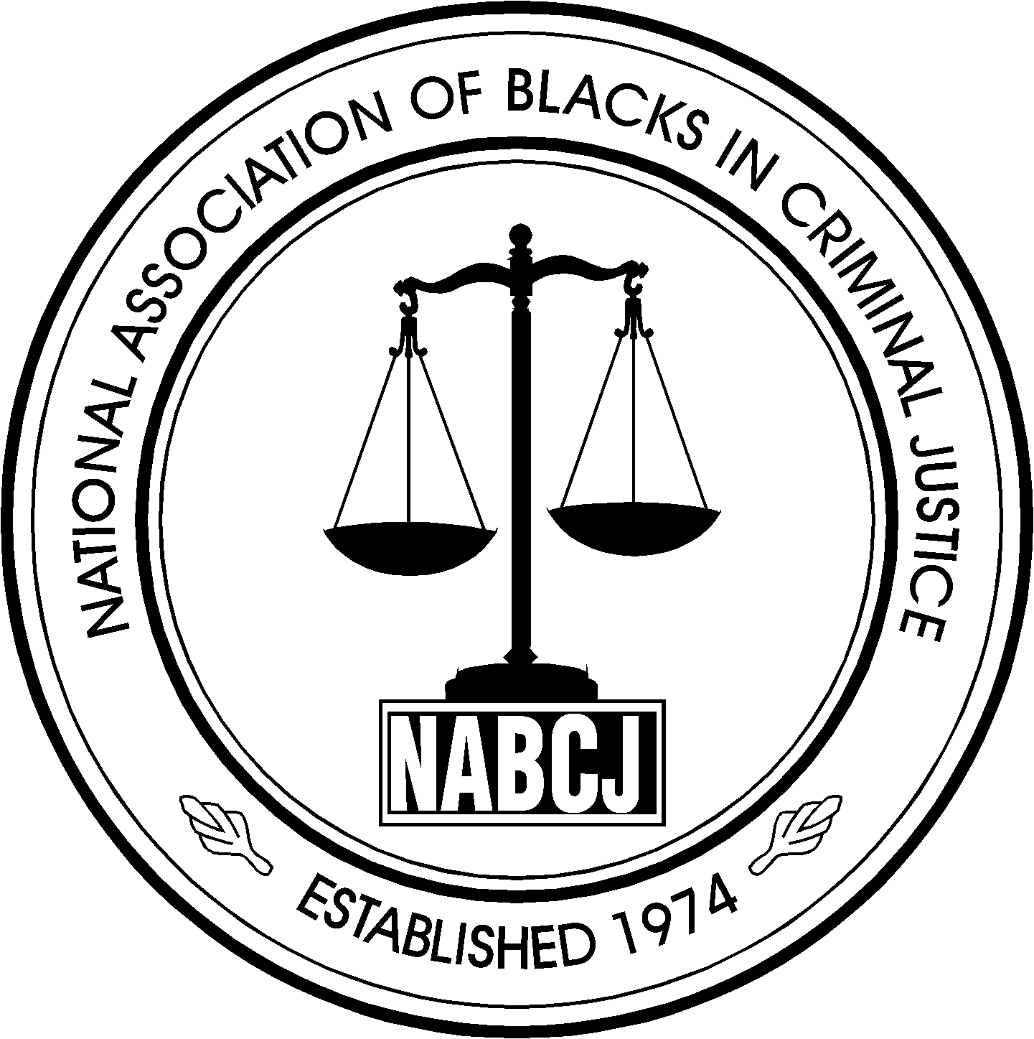

National Association of Blacks in Criminal Justice
P.O. Box 328872  Columbus, Ohio 43232
www.nabcj.org

PLEASE POST

2005 Annual Training Conference Call for Workshop Presentations

“NABCJ: Committed to the Cause of Justice and the Spirit of Unity”
Dayton, Ohio
Submission Deadline April 4, 2005

YOU ARE INVITED to submit proposals for workshop presentations at the 2005 NABCJ Annual Conference. Here is an opportunity for you to share your skills, your insight, your ideas, your programs, your methods, your perspectives, your experience, your present or past job situation - what works and what doesn’t and best practices - to benefit corrections, criminal justice programs and court services professionals in Ohio. It is by sharing with others that we all learn together. Please consider your gifts, your expertise and your experience, review this Call for Workshop Presentations folder, and decide if it would be possible for you to attend the conference as a presenter.

MATERIAL SHOULD BE RELEVANT to one or more segments of the criminals justice, corrections and court services fields, realizing that attendees come from various positions and disciplines in corrections and court services throughout the state of Ohio. All presentations should involve participants in a continuing education experience. (Note training tracks on page 2.) Members and non-members of NABCJ are invited to submit presentation proposals. Over 300 attendees are expected.

Submission Guidelines and Information
NABCJ WORKSHOPS are generally 1 ½ hours in length. If your presentation would be longer, indicate multiples of this time periods. NABCJ grants social work continuing education credits through CHOICES.
THE PROFESSIONALS SUBMITTING THE PRESENTATION PROPOSALS for the program are responsible for contacting all co-presenters and for all details including submission, communication with cabinets, presentation format and audio-visual requests. Presenters pay registration fees for the conference if attending any portion other than their own presentation. NABCJ will provide for required audio-visual equipment, handouts and other necessary expenses ONLY if agreed upon in advance. However, Lap Tops and Power point equipment will not be provided by NABCJ.
PRIORITY IN SELECTION will be given to those presentations that involve creativity, relevance and application to a broad range of corrections and court services professionals.
ABSTRACTS MUST BE RECEIVED no later than April 4, 2005. Notification of acceptance will be made by the end of April, 2005.

PRESENTATION PROPOSALS MUST BE TYPED AND SUBMITTED ON THIS FORM. (Duplicate this form for additional submissions.) If you are using a word processor, you may cut and paste to fit this format and the space provided. No more than two (2) presentations may be submitted by one (1) presenter. No more than four (4) presenters may be listed on each submission.

SUBMISSIONS MUST INCLUDE this completed form and a curriculum vitae or résumé for each presenter. All submissions must be signed by the submitter. Incorrect or incomplete submissions (including lack of résumé) will be returned and not considered until submitted properly.

FOR ADDITIONAL INFORMATION, you may contact Andrea Dean, Conference Coordinator by email at Andrea.Dean@odrc.state.oh.us

Applications should be mailed, faxed or emailed to: Roni Burkes, DPCS 1050 Freeway Drive, North #301 Columbus, Ohio 43229, fax (614) 752-1251 or email ronette.burkes@odrc.state.oh.us

ENCLOSE A SELF-ADDRESSED STAMPED POSTCARD WITH EACH SUBMISSION IF YOU WISH ACKNOWLEDGMENT OF RECEIPT.

NABCJ Information

THE MISSION OF the National Association of Blacks in Criminal Justice is to:
To act upon the needs, concerns, and contributions of African Americans and other people of color as they relate to the administration of equal justice.
The National Association of Blacks in Criminal Justice is a multiethnic, nonpartisan, nonprofit association of criminal justice professionals and community leaders dedicated to improving the administration of justice. The Association was founded as a vehicle by which criminal justice practitioners could initiate positive change from within, while increasing opportunities for the average citizen to better understand the nature and the operation of our local, state, and federal criminal justice processes. Membership and participation in the activities of the Association are open to all, irrespective of race, creed, or country of national origin.
For NABCJ members, criminal justice is more than just a career; it is a commitment to a fundamental aspect of our democracy—justice

Ohio NABCJ MEMBERS AND CONFERENCE ATTENDEES generally fall into the following Affiliates: Akron, Canton, Cincinnati, Cleveland, Columbus, Dayton, Lima, Mansfield, Toledo and Youngstown.

Ohio NABCJ’S CURRENT EXECUTIVE BOARD : Jeffrey E. Carson- President, Linda Bond- President-Elect, Andrea Dean- Vice President, Thomas Teague- Treasurer and Roni Burkes- Secretary.

MEMBERSHIP INFORMATION is available by contacting the Membership Chair, Vernise Robinson at (614) 728-9947 or Vernise.Robinson@odrc.state.oh.us.

NABCJ Workshop Application

1. Title of workshop:_____________________________________________________

- Summary of workshop: Limited to 250 words. Be as specific as possible about the workshop objectives, teaching method and skills to be learned at your presentation. If your presentation is research-based, only completed research with available results may be submitted for a workshop.

- Learning objectives: List the learning objectives, i.e. what participants will know or will be able to do by the end of the presentation. (This information is required by some CEU-granting organizations.)

4. What is new or unique about this material / topic / presentation?

5. Proposed length of workshop:  1-1/2 hours     hours

6. Workshop time slot preference: (This choice does not assure you of this particular slot.)
❑ Monday a.m.  Tuesday a.m.
❑ Monday p.m.  Tuesday p.m.

- This workshop will be of particular interest to whom in the corrections field?

The presentation fits into the following Training Track(s):
(Select one from this group) (Select one or more from this group)
❑ Adult  Institutions  Safety and health
❑ Juvenile  Community corrections  Management
❑ Both adult and juvenile  Legal issues  Substance abuse
❑ Victim services  Other_____________________

PRESENTER AGREEMENT

On behalf of myself and my co-presenters, should this presentation be selected, I/we agree that:
1. Participation in this program does not exempt presenters from paying full registration fees if attending other conference sessions.
2. NABCJ does not pay speaker fees or honorariums for workshop presentations.
3. Individual submitting this proposal and signing this form agrees to receive all conference correspondence and accepts responsibility for conveying conference-related information to co-presenters.
4. Appropriate “Releases of Confidential Information” have been obtained for all client materials that will be used or recorded as part of this presentation. The responsibility for protecting client confidentiality rests with the presenter(s).
5. Presenter(s) will be responsible for informing NABCJ as to needed audio-visual equipment and/or handouts or may bring their own.
6. Individuals submitting or included within this proposal have agreed to be present in Worthington, Ohio , during the hour and date assigned to this presentation at the 2004 NABCJ Annual Conference, and conduct this proposed presentation according to the conditions listed above.

Signature:____________________________________________________________ Date:_________________

Name (print):________________________________________________________________________________

Office phone: ( ) ___________________________________Fax: ( ) ______________________________

